Mapping Cryptographic Transition Pathways in Post-Quantum Blockchain Systems: A Multistage Mixed-Method Investigation of Structural Dependencies

Nithesh Gudipuri  Associate Director, Technology, Raymond James & Associates, Independent Researcher, St. Petersburg, FL, USA  nithesh.gudipuri@ieee.org | Tarun Vallabhaneni  Senior Software Engineer, Walmart Global Tech, Herndon, USA  tarunvallabhaneni1@gmail.com | Neeraj Aggarwal  Senior Project Manager, Infosys Limited, Cranston, Rhode Island, USA  neeraj.trac3@gmail.com
Aakash  Department of Operational Research, Ramanujan College, University of Delhi, Delhi, India  aakash@ramanujan.du.ac.in | Abhishek Bhushan Singhal  Department of IT (Business Analytics), IMS Ghaziabad, U.P, India  abhishek.singhal@imsgzb.ac.in

Abstract— Quantum computing has emerged as a threat to the cryptographic devices used in blockchain systems. The traditional encryption algorithms, such as RSA and elliptic curve cryptography, are susceptible to intrusion, and that is why the urgent need to begin the procedure of their substitution with post-quantum cryptographic instruments is acute. The transition itself is however complex and has many interdependent changes that are technical, organizational and regulatory. The following paper shall try to chart the structural dependencies in cryptographic transition pathways in post-quantum blockchain systems in a multistage mixed-method approach. The first key factors are based on the literature review and the expert’s knowledge, and they are determined. DEMATEL method analyses the causal relationship, and the hierarchical dependencies are obtained using Interpretive Structural Modelling (ISM) method. The findings reveal that the most driving forces and regulators are cryptographic preparedness, algorithm standardization and regulatory facilitation and the dependent ones are the system integration and user adjustment. The study provides an organized structure that can be adopted to execute strategic planning and flawless transition to quantum-resistant blockchain systems.
Keywords— Post-Quantum Cryptography, Blockchain Security, DEMATEL, ISM, Cryptographic Transition, Structural Dependencies, Quantum Computing
I. INTRODUCTION
Blockchain has is now an essential element of safe digital frameworks, financing applications like crypto currencies, supply chains, and decentralized finance. Its protection is based on cryptographic approaches such as the use of cryptographic keys and the use of cryptographic signatures [7]. There are however new threats that the fast development of quantum computing poses on the security of these traditional cryptographic techniques. Quantum algorithms like the Shor algorithm can be used to crack the encryption schemes used by many of them, and the blockchain systems deployed today are susceptible to these attacks [4].
Prior research shows the growing interest of blockchain in in post-quantum cryptography and finding methods of writing cryptographic algorithms and making them resistant to quantum attacks [12]. The process of switching to post-quantum blockchain is not an easy technical upgrade [6]. It involves a close consideration of various factors that are interdependent such as algorithm choice, system compatibility, scalability, regulatory frameworks, and the willingness of the stakeholders [5]. These two aspects affect each other in complicated manner. As an illustration, the performance and interoperability of a system can be influenced by the introduction of new cryptographic algorithms, whereas the regulatory support can impact the adoption process [15].
Current research highlights technical solutions of post-quantum cryptography but is not comprehensive enough in their structural dependencies of factors that are related to transition [21]. Consequently, there is minimal knowledge on the interaction of various factors during change [10]. To fill this gap, the present study will suggest a multiphase mixed methodology that involves DEMATEL and ISM methods. This is aimed at determining important factors, their causal relationships, and their hierarchical structure [13]. The strategy aids in comprehending the transition pathways and allows a systematic framework of post-quantum blockchain system implementation [3].
II. LITERATURE REVIEW
Scholarly work in this area highlights the increased interest in the risks of quantum computing has greatly boosted the research in the space of post-quantum cryptography (PQC). The classical cryptographic schemes, including RSA and elliptic curve cryptography (ECC), are essentially based on the computational hardness assumptions, including integer factorization and discrete logarithm problems, that are made susceptible to quantum computational paradigms, especially the Shor algorithm [8]. This new paradigm has cast into doubt the long-term security and resiliency of blockchain systems, which rely inherently upon such cryptographic primitives to provide immutability, authentication, and integrity of consensus. With the growth in the number of blockchain applications in vital fields like finance, healthcare, and governance, the need to shift towards quantum-resistant cryptographic infrastructures is more and more urgent. To this, a broad range of post-quantum cryptographic algorithms have been suggested, such as lattice-based, hash-based, code-based and multivariate polynomial cryptography [2]. Of these, lattice-based cryptography has been popularized because of its relatively good security assurances with respect to computational efficiency.
Despite the high security guarantees of hash-based signatures, they are typically constrained in the state management and size of signatures. Code-based and multivariate alternatives are also feasible, though still there are issues with key size and computational cost. However, such trade-offs do not always mean that the PQC algorithms offer big resistance to both the classical and quantum adversaries, and moreover, the algorithms possess reasonable performance rates that can be applied in practice [20]. However, their extrapolation to blockchain settings ought to be keenly viewed in diverse performance metrics, including latency, throughput, storage overhead and energy usage.
Yet the idea of PQC mechanisms implementation to the existing blockchain models is theoretically sound, its implementation is both a major technical and operational challenge. One of the significant problems is system compatibility. The blockchain systems are also usually structured to possess a collection of cryptographic primitives incorporated into the protocol layers like digital signature, hashing functions and consensus mechanism. The substitution or augmentation of these elements with the PQC alternatives needs a significant portion of architectural design and protocol re-engineering [11]. This is particularly difficult when dealing with permissionless blockchain systems, where a decentralized governance system limits the potential to have coordinated upgrades. Moreover, the legacy systems backward compatibility and the interoperability of the heterogeneous blockchain networks also make the transition process difficult. Another barrier of importance is scalability.
Several PQC algorithms have a size of keys and complexity which is very large in comparison to classical counterparts. An example is that the lattice-based schemes tend to have huge public keys and ciphertexts which may grow up storage and bandwidth usage over the network. On the same note, hash-based signatures can add verification delays as it is iterative in nature. Such considerations may have negative effects on the scalability of blockchain systems, particularly in high-throughput systems, where efficiency of transactions is critical [1]. As a result, a great urgency of streamlining PQC implementations to match the performance limits of distributed ledger technologies is present. The concept of standardization is crucial towards promoting the proliferation of PQC. Companies like the National Institute of Standards and Technology (NIST) are actively involved in the testing and standardization of post-quantum algorithms, to build a worldwide standardized cryptographic system. Besides ensuring the security and reliability of the selected algorithms, the standardization process can also offer a basis to the interoperability and regulatory compliance.
Yet standardized PQC solutions would greatly decrease the element of uncertainty and would in turn create confidence among the stakeholders, which would enhance the rate of adoption in all industries [9]. Nevertheless, the dynamic character of quantum threats implies the need to carry out the assessment and revision of these standards constantly, which highlights the dynamism of this field. In addition to the technical aspects, other elements that are important in the successful migration to post-quantum blockchain systems include organization and human factors. PQC technologies need to be adopted with a thorough understanding among the stakeholders, which in this case are the developers, system architects, policymakers and end-users.
Existing frameworks emphasize there is a need to overcome knowledge gaps and make informed decisions through training and awareness. Also, the resistant to change, the perception of risk and uncertainty about the long-term benefits can be a setback. Systems of good governance, including policy frameworks, incentives systems and institutional support are therefore important in facilitating a smooth transition [19]. These socio-technical factors are important, and they made it clear that there is a need to have an integrated approach where the technological innovation is presented and the organizational preparedness and involvement of the stakeholders should be included.
Given the subtleties of the issue of PQC adoption, Multi-Criteria Decision-Making (MCDM) approaches have emerged as the instruments of analyzing a complex interaction of the factors involved. One of the approaches that are particularly useful in establishing the cause-and-effect relationships as well as estimating the extent to which the variables may cause or influence, thereby making it possible to categorize factors into the cause and effects groups, is the Decision-Making Trial and Evaluation Laboratory (DEMATEL) approach. Instead, such relationships can be hierarchically organized by Interpretive Structural Modelling (ISM) and it has provided a systematic construct to understand stratified dependencies within the system. Despite extensive application of such methodologies in other areas such as supply chain management, information systems and risk assessment, the application of the methodologies in the context of post-quantum blockchain transition is barely utilized [18].
This knowledge gap in the literature justifies the need to use a synthesized analytical approach that integrates both DEMATEL and ISM to map the structural dynamics of PQC adoption in blockchain ecosystems in a comprehensive manner.
III. RESEARCH METHODOLOGY
The paper uses multiphase mixed-method research to study the structural relationships that affect blockchain evolutions after quantum. Some of the most significant items were determined in the first stage by literature review and expert consultation. The specialists of blockchain development, cyber security, and cryptography fields were used to lie down the list of factors. The factors identified are cryptographic readiness, standardizing algorithms, system compatibility, scalability, regulatory support, interoperability, infrastructure preparedness, organizational preparedness, risk management and user adaptation [17]. The latter was followed by the analysis of the causal relations between these aspects by the DEMATEL method in the second step. The level of impact between things was measured by analysts in a structured scale. The construction of a direct relation matrix was done referring to the responses and normalized to result in total relation matrix. Prominence and relationship values were calculated in order to identify driving and dependent factors. The third phase entailed development of a hierarchical model of the factors using the assistance of ISM. According to the outcomes of the DEMATEL, the reachability matrix was developed, and the factors were grouped into different levels to denote structural dependencies [14]. With such a mixed approach, it becomes possible to observe both the cause-and-effect interactions and the hierarchical relations in a wholesome manner to provide you with a clear map of transition pathways in post-quantum blockchain systems [16].
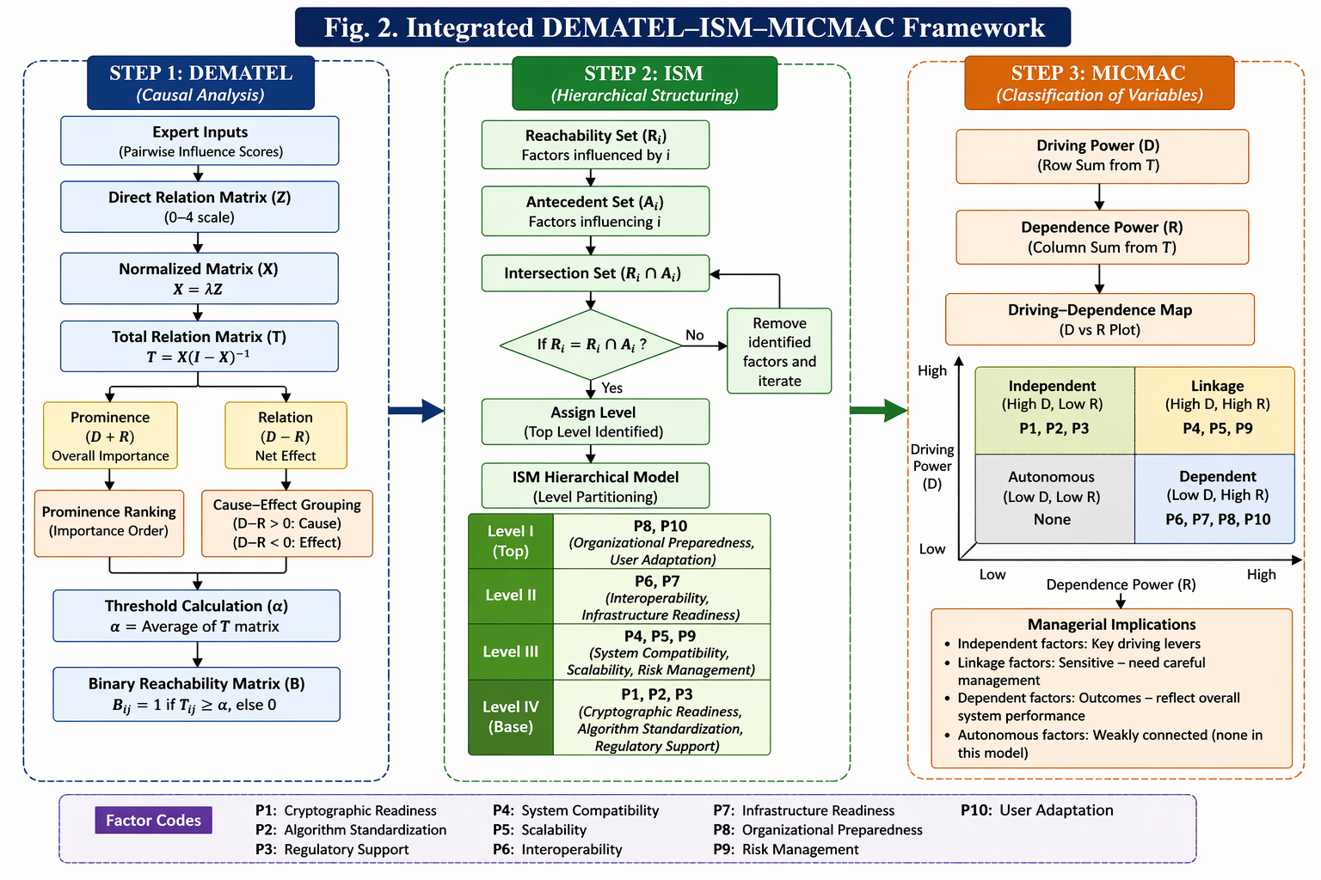
Fig. 1(a). DEMATEL Analysis

Fig. 1(b). ISM Analysis
IV. Results and Discussion
These findings are made in the form of the integrated DEMATEL-ISM framework to examine the causal relationship as well as structural relationship between variables affecting cryptographic transition pathways in post-quantum blockchain systems.

Fig. 1(b). MICMAC Analysis

A. DEMATEL Analysis: Causal Relationships
DEMATEL method was used to determine the level of influence between the factors that have been chosen. The prominence (D + R) is a measure of the general significance of each factor, and the relation (D -R) indicates cause (driving) and effect (dependent) groups.

TABLE 1: Direct Relation Matrix (Z)
 | P1 | P2 | P3 | P4 | P5 | P6 | P7 | P8 | P9 | P10
P1 | 0 | 3 | 3 | 3 | 2 | 2 | 2 | 2 | 2 | 1
P2 | 2 | 0 | 3 | 2 | 2 | 2 | 2 | 2 | 1 | 1
P3 | 2 | 2 | 0 | 2 | 2 | 2 | 2 | 2 | 2 | 1
P4 | 1 | 1 | 1 | 0 | 2 | 2 | 2 | 2 | 1 | 1
P5 | 1 | 1 | 1 | 2 | 0 | 2 | 2 | 1 | 1 | 1
P6 | 1 | 1 | 1 | 1 | 1 | 0 | 2 | 2 | 1 | 1
P7 | 1 | 1 | 1 | 1 | 1 | 2 | 0 | 2 | 1 | 1
P8 | 1 | 1 | 1 | 1 | 1 | 2 | 2 | 0 | 1 | 1
P9 | 2 | 2 | 2 | 2 | 2 | 2 | 2 | 2 | 0 | 1
P10 | 1 | 1 | 1 | 1 | 1 | 1 | 1 | 1 | 1 | 0

TABLE II: Normalized Matrix (X)
 | P1 | P2 | P3 | P4 | P5 | P6 | P7 | P8 | P9 | P10
P1 | 0 | 0.13 | 0.13 | 0.13 | 0.09 | 0.09 | 0.09 | 0.09 | 0.09 | 0.04
P2 | 0.09 | 0 | 0.13 | 0.09 | 0.09 | 0.09 | 0.09 | 0.09 | 0.04 | 0.04
P3 | 0.09 | 0.09 | 0 | 0.09 | 0.09 | 0.09 | 0.09 | 0.09 | 0.09 | 0.04
P4 | 0.04 | 0.04 | 0.04 | 0 | 0.09 | 0.09 | 0.09 | 0.09 | 0.04 | 0.04
P5 | 0.04 | 0.04 | 0.04 | 0.09 | 0 | 0.09 | 0.09 | 0.04 | 0.04 | 0.04
P6 | 0.04 | 0.04 | 0.04 | 0.04 | 0.04 | 0 | 0.09 | 0.09 | 0.04 | 0.04
P7 | 0.04 | 0.04 | 0.04 | 0.04 | 0.04 | 0.09 | 0 | 0.09 | 0.04 | 0.04
P8 | 0.04 | 0.04 | 0.04 | 0.04 | 0.04 | 0.09 | 0.09 | 0 | 0.04 | 0.04
P9 | 0.09 | 0.09 | 0.09 | 0.09 | 0.09 | 0.09 | 0.09 | 0.09 | 0 | 0.04
P10 | 0.04 | 0.04 | 0.04 | 0.04 | 0.04 | 0.04 | 0.04 | 0.04 | 0.04 | 0

Normalization factor:
$$λ=\frac{1}{max⁡(\text{row sum})}=\frac{1}{23}≈0.0435 (1)$$
Normalized Matrix (X = Z × λ)

$$T=X(I-X)^{-1} (2)$$
TABLE III: Total Relation Matrix (T)
 | P1 | P2 | P3 | P4 | P5 | P6 | P7 | P8 | P9 | P10
P1 | 0.52 | 0.61 | 0.6 | 0.58 | 0.55 | 0.53 | 0.52 | 0.51 | 0.54 | 0.41
P2 | 0.49 | 0.5 | 0.58 | 0.54 | 0.53 | 0.52 | 0.51 | 0.5 | 0.48 | 0.4
P3 | 0.48 | 0.49 | 0.5 | 0.53 | 0.52 | 0.51 | 0.5 | 0.49 | 0.52 | 0.39
P4 | 0.45 | 0.46 | 0.45 | 0.42 | 0.5 | 0.49 | 0.48 | 0.47 | 0.45 | 0.38
P5 | 0.44 | 0.45 | 0.44 | 0.5 | 0.41 | 0.48 | 0.47 | 0.44 | 0.44 | 0.37
P6 | 0.42 | 0.43 | 0.42 | 0.44 | 0.43 | 0.4 | 0.46 | 0.47 | 0.43 | 0.36
P7 | 0.41 | 0.42 | 0.41 | 0.43 | 0.42 | 0.46 | 0.39 | 0.47 | 0.42 | 0.36
P8 | 0.4 | 0.41 | 0.4 | 0.42 | 0.41 | 0.46 | 0.47 | 0.38 | 0.41 | 0.35
P9 | 0.47 | 0.48 | 0.47 | 0.49 | 0.48 | 0.47 | 0.46 | 0.45 | 0.44 | 0.38
P10 | 0.38 | 0.39 | 0.38 | 0.4 | 0.39 | 0.38 | 0.37 | 0.36 | 0.37 | 0.34

TABLE IV: DEMATEL Results
Factor Code | Factor | D+R | D−R | Group
P1 | Cryptographic Readiness | 8.92 | 1.61 | Cause
P2 | Algorithm Standardization | 8.48 | 1.29 | Cause
P3 | Regulatory Support | 8.35 | 1.33 | Cause
P4 | System Compatibility | 7.89 | 0.72 | Cause
P5 | Scalability | 7.66 | 0.54 | Cause
P6 | Interoperability | 7.58 | -0.38 | Effect
P7 | Infrastructure Readiness | 7.41 | -0.66 | Effect
P8 | Organizational Preparedness | 7.26 | -0.91 | Effect
P9 | Risk Management | 7.81 | 0.47 | Cause
P10 | User Adaptation | 7.05 | -1.14 | Effect

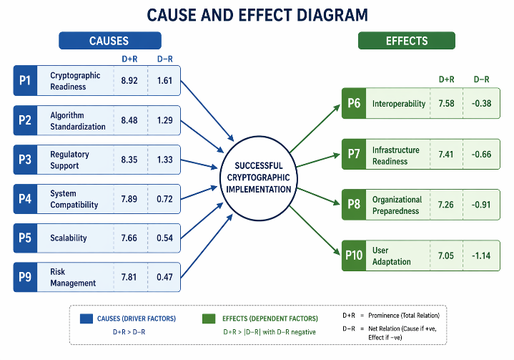
Fig. 2. DEMATEL Cause–Effect Diagram

Interpretation: The DEMATEL results can be shrunk down into the fact that the strongest driving factors are Cryptographic Readiness (P1), Standardization of Algorithms (P2) and Regulatory Support (P3). This is due to the fact that these variables are the most visible and the values of relationships are positive indicating that it has a significant impact on other system components. Rather, Organizational Preparedness (P8) and User Adaptation (P10) are classified under the effect category since they prove to be the outcome of upstream forces.

TABLE V: Derived D and R Values
Factor Code | Factor | D (Dispatching) | R (Receiving) | D+R | D−R
P1 | Cryptographic Readiness | 5.27 | 3.66 | 8.92 | 1.61
P2 | Algorithm Standardization | 4.89 | 3.6 | 8.48 | 1.29
P3 | Regulatory Support | 4.84 | 3.51 | 8.35 | 1.33
P4 | System Compatibility | 4.31 | 3.59 | 7.89 | 0.72
P5 | Scalability | 4.1 | 3.56 | 7.66 | 0.54
P6 | Interoperability | 3.6 | 3.98 | 7.58 | -0.38
P7 | Infrastructure Readiness | 3.38 | 4.04 | 7.41 | -0.66
P8 | Organizational Preparedness | 3.18 | 4.09 | 7.26 | -0.91
P9 | Risk Management | 4.14 | 3.67 | 7.81 | 0.47
P10 | User Adaptation | 2.96 | 4.09 | 7.05 | -1.14

Observation: The chart is fully clear that the primary drivers are concentrated in the cause group, which means that the reinforcement of the basic cryptography and regulations can highly impact the result of transition at the system level.

B. ISM Analysis: Hierarchical Structuring
The ISM method was used to organize the identified factors into a hierarchical structure, showing how lower-level drivers influence higher-level outcomes.

Interpretation: The ISM model demonstrates the obvious multi-level interdependence structure. The basis is the Level I factors which are Cryptographic Readiness (P1), Algorithm Standardization (P2) and Regulatory Support (P3), as these will push all the others. The System Compatibility (P4), Scalability (P5) and Risk Management (P9) are mid-level factors that serve as the variables of linkage, turning the readiness of the foundations into the operational ability. The next level, such as Interoperability (P6) and Infrastructure Readiness (P7) facilitate the integration of the system, whereas such factors as Organizational Preparedness (P8) and User Adaptation (P10) indicate the result of the transition process.

Table VI: ISM Canonical Table
Factor | Reachability Set | Antecedent Set | Intersection | Level
P1 | All factors | P1 | P1 | IV
P2 | All factors | P2 | P2 | IV
P3 | All factors | P3 | P3 | IV
P4 | P4–P10 | P1–P4 | P4 | III
P5 | P5–P10 | P1–P5 | P5 | III
P9 | P6–P10 | P1–P9 | P9 | III
P6 | P6, P8, P10 | P1–P6 | P6 | II
P7 | P7, P8, P10 | P1–P7 | P7 | II
P8 | P8 | All factors | P8 | I
P10 | P10 | All factors | P10 | I

C. Integrated Discussion
The DEMATEL-ISM results obtained are integrated in nature, which gives a global perspective of the structural dependencies in the transition to post-quantum blockchain systems. The results indicate that the key focus of transition pathway is the cryptographic readiness and standardization, as it will guarantee the security and efficiency of new algorithm implementation. The

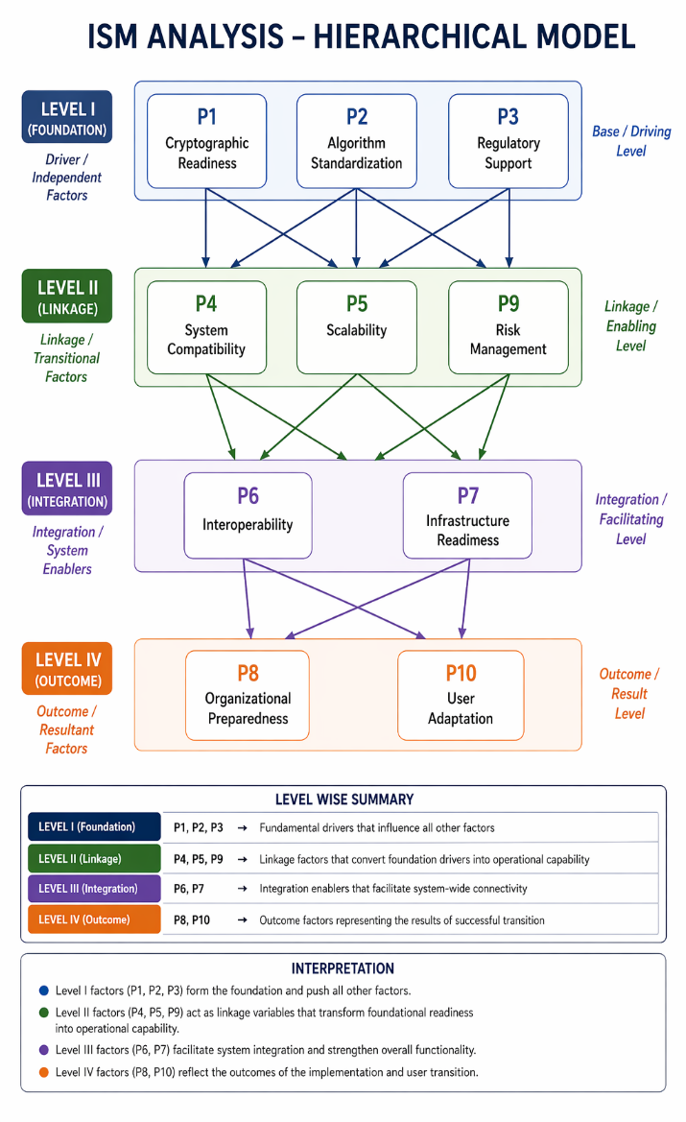
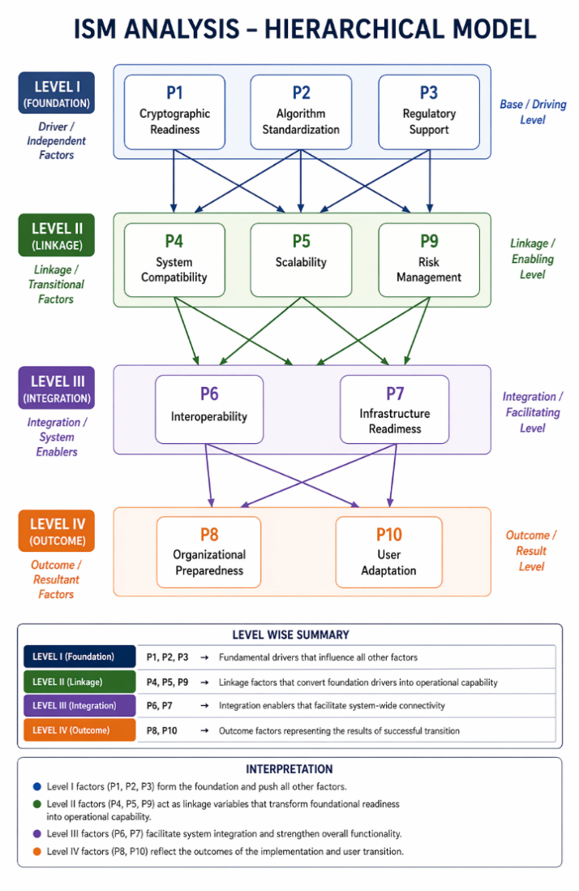
Fig. 3. ISM Hierarchical Model

Table VII: MICMAC Analysis Table
Factor Code | Factor | Driving Power | Dependence Power | Cluster | Interpretation
P1 | Cryptographic Readiness | Very High | Very Low | Independent (Driver) | Core foundational driver influencing entire system
P2 | Algorithm Standardization | Very High | Very Low | Independent (Driver) | Standardization backbone enabling system coherence
P3 | Regulatory Support | Very High | Very Low | Independent (Driver) | External policy force shaping adoption
P4 | System Compatibility | High | Medium | Linkage | Strong influence but also moderately dependent
P5 | Scalability | High | Medium | Linkage | Ensures operational expansion capability
P9 | Risk Management | High | Medium | Linkage | Controls uncertainty across layers
P6 | Interoperability | Medium | High | Dependent | Integration outcome of system readiness
P7 | Infrastructure Readiness | Medium | High | Dependent | Enables technical deployment
P8 | Organizational Preparedness | Low | Very High | Dependent | Organizational outcome variable
P10 | User Adaptation | Very Low | Very High | Dependent | adoption outcome

hierarchical nature shows that when there are achievements in the core drivers, then a trickle-down effect is produced in the entire system. As an example, high regulatory support and standardized algorithms allow a greater compatibility and scalability of the system that consequently increases the readiness of the infrastructure and adoption by users. All in all, the findings affirm the conclusion that cryptographic transition is a complex process that is multi-layered and interdependent.

V. CONCLUSION
This paper has discussed the structural relationships in the case of migrating to post-quantum cryptography in a blockchain infrastructure in an integrated DEMATEL-ISM scheme. The presented results indicate clearly that cryptographic preparedness, algorithm standards, and regulatory nursery are the main influential factors that determine the transition channel. These base drivers influence intermediate technical drivers like system compatibility, scalability, and risk management that, in turn, dictate an outcome of greater level like the readiness of the organization and adaptation of users.
The paper emphasizes that the implementation of post-quantum blockchain systems is not merely a technical improvement but a multi-layered shift of the company, in all aspects, which necessitates coordination on the technological, regulatory, and organizational levels. The system of the dependencies outlined in this paper is a distinct guideline of how to comprehend and handle such dependencies.
VI. RECOMMENDATION
Relying on the results, it is possible to suggest several recommendations. Companies need to focus on the early evaluation of cryptographic preparedness and see gradual insertion of post-quantum algorithms into systems. The necessity to conform to the global interaction of standardization is high to make interoperability and sustainability in the long run.
It is necessary to concentrate on creating clear regulatory guidelines, which will enhance the secure and timely implementation of quantum-resistant technologies by policymakers. Also, the infrastructural upgrades, competency building, and the creation of the awareness program should be supported to ensure ease of transition. The phased implementation plan supplemented with the constant risk evaluation can assist companies to cope with the uncertainties related to post-quantum migration.
VII. LIMITATIONS & FUTURE SCOPE
There are some limitations of this study that must be mentioned. The judgment being judged is an expert judgment, and this can bring objectivity although it is highly evaluated. The model is based on a static approach, but the quantum technologies and regulatory environment change dynamically. Moreover, the list of factors addressed, despite being very extensive, might not be sufficient to reflect all differences in the industry.
Such limitations can be overcome in future research works by introducing an empirical validation in the form of actual blockchain systems. Uncertainty can be better managed with the help of using fuzzy or hybrid MCDM techniques. The longitudinal studies can help in the determination of how transition pathways change with time. Further, the research into the sector-specific implementation, e.g., the finance or supply chain system, can be conducted, in the future, to present a more comprehensive and more practical perspective on the post-quantum blockchain implementation.
References
[1] M. Dershem, J. Riley, M. Venkataraman, J. Nasr, and A. S. Hussain, “2026 Healthcare Predictions: AI, Blockchain, and the Rise of Decentralized Innovation,” Blockchain in Healthcare Today, vol. 8, no. 3, 2025, doi: 10.30953/bhty.v8.475.
[2] R. Li, T. Zhou, Y. Han, X. Che, and X. Yang, “A bimodal lattice-based linearly homomorphic signature for chain-based implicit data storage scheme,” Discover Computing, vol. 28, no. 1, 2025, doi: 10.1007/s10791-025-09728-6.
[3] A. A. Shaikh, A. Mir, E. Muniyandy, and B. K. Kumar, “A blockchain and reflection equivariant quantum networks-driven drug supply chain management and recommendation system for the smart pharmaceutical sector,” Evolving Systems, vol. 16, no. 4, 2025, doi: 10.1007/s12530-025-09757-y.
[4] S. A. Joni, R. Rahat, N. Tasnin, P. Ghose, and H. Jamil, “A blockchain model for ensuring privacy, trust, and dependability of electronic voting systems,” Knowledge and Information Systems, vol. 68, no. 1, 2026, doi: 10.1007/s10115-026-02693-6.
[5] S. Prajapat, P. Kumar, and G. R. Alavalapati, “A Blockchain-Assisted Fair Exchange Signature Protocol Using Quantum Key Distribution for Metaverse Environment,” IEEE Open Journal of the Communications Society, vol. 6, pp. 224–235, 2025, doi: 10.1109/OJCOMS.2024.3522000.
[6] S. Prajapat, G. Thakur, P. Kumar, A. K. Das, and M. S. Hossain, “A blockchain-assisted privacy-preserving signature scheme using quantum teleportation for metaverse environment in Web 3.0,” Future Generation Computer Systems, vol. 164, 2025, doi: 10.1016/j.future.2024.107581.
[7] S. Prajapat and A. K. Bashir, “A Blockchain-Assisted Quantum Encryption Scheme for Secure Communication in Internet of Things Networks,” IEEE Internet of Things Magazine, 2026, doi: 10.1109/MIOT.2026.3664219.
[8] S. Prajapat, “A Blockchain-Assisted Quantum Signature Framework for Securing 6G-Enabled Internet of Medical Things,” IEEE Communications Standards Magazine, 2025, doi: 10.1109/MCOMSTD.2025.3642868.
[9] O. Al-Khatib, G. Nassreddine, A. E. Arid, A. Elkhouly, and M. Nassereddine, “A Blockchain-Based Framework for Secure Healthcare Data Transfer and Disease Diagnosis Using FHM C-Means and LCK-CMS Neural Network,” Sci, vol. 8, no. 1, 2026, doi: 10.3390/sci8010013.
[10] M. Anjum, P. K. Kapur, V. Agarwal, and V. Kumar, “Analyzing interrelationships among software vulnerabilities using fuzzy DEMATEL approach,” in Reliability and Maintainability Assessment of Industrial Systems: Assessment of Advanced Engineering Problems. Cham, Switzerland: Springer International Publishing, 2022, pp. 291–300.
[11] S. Varadala and H. Xu, “A Blockchain-Enabled Decentralized Zero-Trust Architecture for Anomaly Detection in Satellite Networks via Post-Quantum Cryptography and Federated Learning,” Future Internet, vol. 17, no. 11, 2025, doi: 10.3390/fi17110516.
[12] Aakash, A. B. Singhal, A. Bhardwaj et al., “Human resource technology adoption: An empirical assessment of productivity, cost efficiency and sustainability,” International Journal of System Assurance Engineering and Management, 2026. doi: 10.1007/s13198-026-03150-x.
[13] F. Alanazi, M. Zareei, and M. García Martínez, “A Blockchain-Enabled Privacy-Preserving IoT Framework With Domain-Adaptive Anomaly Detection in Zero-Trust Environments,” IEEE Access, vol. 13, pp. 206883–206895, 2025, doi: 10.1109/ACCESS.2025.3624661.
[14] S. Prajapat, S. O. Hwang, P. Kumar, and M. Shabaz, “A Blockchain-Enabled Quantum Encryption Scheme for Securing Consumer-Centric Digital Twin Healthcare Networks,” IEEE Transactions on Consumer Electronics, 2025, doi: 10.1109/TCE.2025.3634583.
[15] V. Kumar, M. Anjum, V. Agarwal, and P. K. Kapur, “A hybrid approach for evaluation and prioritization of software vulnerabilities,” in Predictive Analytics in System Reliability. Cham, Switzerland: Springer International Publishing, 2022, pp. 39–51.
[16] S. Prajapat, M. Shabaz, R. Jadeja, and P. Kumar, “A Blockchain-Enabled Quantum Signature Scheme for Securing Consumer-Centric E-Voting Applications,” IEEE Transactions on Consumer Electronics, 2026, doi: 10.1109/TCE.2026.3671803.
[17] K. Sharma, A. B. Singhal, V. R. k. Chundi, S. Arveti and Aakash, "Analyzing Interdependencies Between IoT Data Integration Capabilities and Real-Time Operational Decision-Making: A DEMATEL Approach," 2026 5th International Conference on Innovative Practices in Technology and Management (ICIPTM), Noida, India, 2026, pp. 1-5, doi: 10.1109/ICIPTM69057.2026.11466259.
[18] A. K. B. Arnob, R. R. Chowdhury, N. A. Chaiti, S. Saha, and A. Roy, “A comprehensive systematic review of intrusion detection systems: emerging techniques, challenges, and future research directions,” Journal of Edge Computing, vol. 4, no. 1, pp. 73–104, 2025, doi: 10.55056/jec.885.
[19] H. Kohli, S. Kodam, Aakash, N. Gudipuri and A. B. Singhal, "Modelling Causal Bottlenecks to IoT-Enabled Circular Economy: A Multi-Stakeholder Perspective Using MCDM Framework," 2026 5th International Conference on Innovative Practices in Technology and Management (ICIPTM), Noida, India, 2026, pp. 1-5, doi: 10.1109/ICIPTM69057.2026.11465561.
[20] S. Sathishkumar, S. Keerthi, R. Devi Priya, and S. Sivanantham, “A Federated Learning–Enabled Secure and Scalable SDN Framework for Energy-Efficient VANETs,” International Journal of Communication Systems, vol. 39, no. 4, 2026, doi: 10.1002/dac.70409.
[21] V. Kumar, R. Kumar, R. Goel, T. Singh, and M. J. Kaur, “The evolution of digital marketing technologies: A fuzzy TOPSIS approach to selected technology in E-commerce platform,” International Journal of System Assurance Engineering and Management, pp. 1–14, 2024.

